Logo
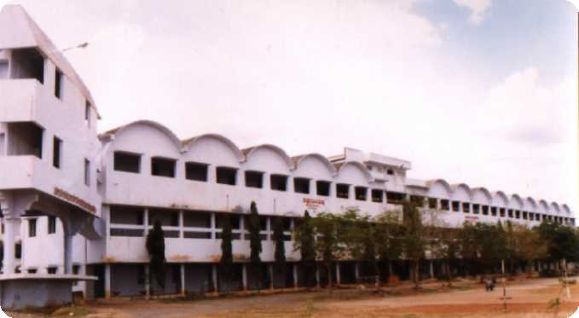

Paladugu Nagaiah Chowdary &
Kotha Rahuramaiah Degree College
Narasaraopet – 522 601

Paladugu Nagaiah Chowdary and Kotha Raghuramaih Degree College, Narasaraopet, is an institution under permanent affiliation to Nagarjuna University. It was set up in the academic year 1991-92.

The Idea of Establishing the Institution

It is a well-known fact that there are many degree colleges in Narasaraopet. The college Secretary and Correspondent Dr. Medarametla Sivalinga Prasasada Rao aimed at providing an alternative mode of education.

By this desire new science courses, which were not available in many other degree colleges, were started. The college offers the “need-based education” since its inception; it has been making the historic attempts to promote education. The Management moulds the students into worthy individuals who can confidently face the challenges of the millennium.

Courses Offered for BA

B.A.,

S.No. | Course Name | Medium | Subjects
 |  | Telugu / English | Part - I |  |  | Part - II
Arts Group
1. | B.A. | Telugu | English | Telugu / Sanskrit | Indian Heritage & Culture | Economics | Public Administration | Political Science
2. | B.A. | Telugu | English | Telugu / Sanskrit | Indian Heritage & Culture | History | Political Science | Economics
3. | B.A. | English | English | Telugu / Sanskrit | Indian Heritage & Culture | History | Political Science | Special English

Note: If there is no sufficient strength in a particular group in any degree course, the Principal has the right to change the admission in to another group (or) combination of subjects, as per availability.
NSS
One unit of N.S.S. facility is available in the college.
NCC
One company N.S.S. facility is available in the college.
Admission - Eligibility
Admission for B.A (All Groups)., B.Com., B.sc (All Groups)., & B.B.M. courses.
- Applicant should have completed intermediate or P.U.C. or its equivalent examination.
- Students seeking admission in B.Sc., must study two group subjects in intermediate (or) its equivalent courses.
- Documents that must accompany the filled in application form are
  - Intermediate marks certificate.
  - Transfer certificate in original from the college last attended.
  - Conduct certificate.
- The students from universities other than Nagarjuna University(N.U.) must submit the migration certificate.
- A 9X4 self addressed cover with Rs.3/- stamps affixed on it.
- A recent passport size photograph affixed on the application form.
- The original certificates along with three(3) recent passport size photographs should be submitted at the time of interview.
- Five(5) self addressed postal cards.
- Students belonging to the schedule Caste (SC)/ schedule Tribe (ST)/ Backward Caste (BC), should enclose the Caste Certificate issued by a competent authority (M.R.O.).
Admission - Procedure
- Applications for admissions should be made in the prescribed form only.
- Application forms are separate for each course.
- Prospectus and Application form can be obtained from the college office on payment of Rs.20/- in cash (or) Rs.25/- by Money Order
- Photo Copies of all required documents must be attested by a Gazetted officer and should be submitted along with the application form.
- Original Certificates are to be produced at the time of the interview.
- Any false information given by the student may result in cancellation of admission without any notice or intimation.
- The applicant should write the correct permanent and temporary address with pin code.
- Signature of the Parent/ Guardian/ Husband is must.
- Filled in applications should be submitted / mailed to the college office on or before the date mentioned on the application.
- The College / Institute is not responsible for any postal delays in receiving of the application in time.
- List of selected candidates for the interview will be kept in the college Notice Board. Applicants should attend the interview at the mentioned time along with his Parent / Guardian.
Discipline
- Students should not resort to strikes or demonstrations within the college premisis.
- For charges of miscoduct by student(s) in any manner, the committee may recommend about the penalty to be imposd which may range from suspesnion to expulsion from the college.
- The Parent / Guardian of the student should take the responsibility for the loss of damages caused by the students to the property of the institute.
Attendance
- Students are not permitted to appear for the University examination without having the minimum (75%) of attendance as per the rules of the University be in vogue.
- Students not having 75% of attendance are not eligible for receiving the government scholarships.
- Students who have not completed compositions, practicals, etc., as per the university rules are not eligible to appear for the University Examinations.
- Students who do not attend the class exams - term exams will not be permitted to write the university examinations.
- As per the rules of the Government, students who do not pass atleast half of the subjects will have to continue in the same class.
Tuition Fee and Other Fess
The students qualified after interview will have to pay the following fees with in the stipulated time frame, failing which the admission is liable for cancellation.

S.No. | Fee Type | Amount (Rs.)
1. | Tuition Fee per Academic year | 720.00
2. | Laboratory Fee (MPC) | 300.00
3. | Stationary Fee | 50.00
4. | Library & Reading Room Fee | 40.00
5. | Admission Fees | 10.00
6. | Magazine Fee | 15.00
7. | Medical Fee | 2.00
8. | Sports Fee | 50.00
9. | University Sports Fee | 15.00
10. | Registration Fee | 2.00
11. | Anniversary Fee | 25.00
12. | Matriculation Fee | 25.00
13. | Literary and Dramatic Association Fee | 10.00
14. | Breakages | 25.00
15. | Audio - Visuals | 15.00
16. | University Youth Festival Fund | 5.00

Note: 1.The fee once paid will not be refunded under any circumstances.
2. The fee(s) may change in future with out any further notice.

